# Web Fundamentals Lab

This document defines Lab assignment from the [“Web Fundamentals (HTML & CSS)“ Course @ SoftUni](https://softuni.bg/courses/web-fundamentals/). Please submit as homework a single zip / 7z archive holding the source code of all below described problems.

## Problem 7.* Drop-down Menu

In the **HTML** document **header** tag make the menus drop-down like the screenshot below

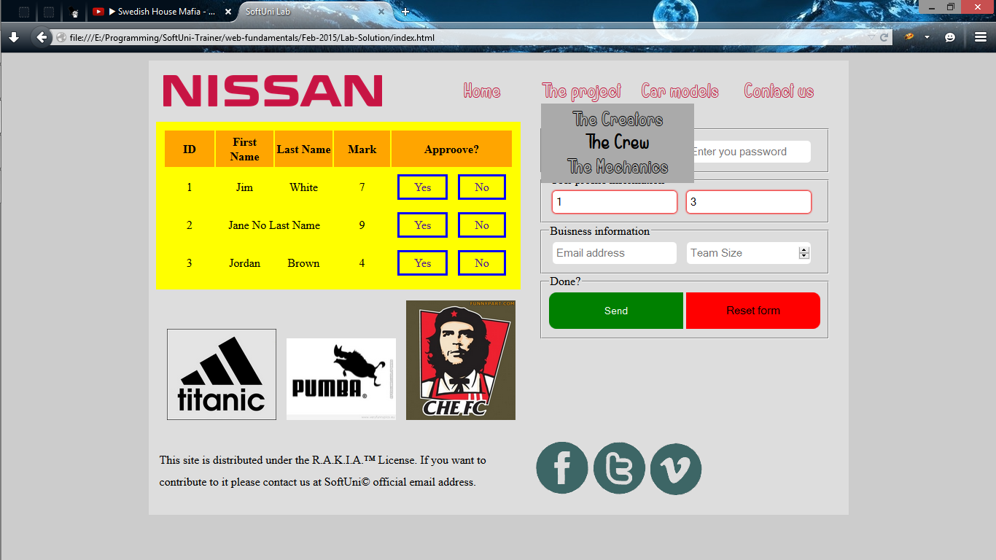

## Problem 8.** Music Playing

In the **HTML** document add **audio** tag that plays the file “**yo-mama.mp3**” on page load.

## Problem 9.*** Drop-down Menu

In the **HTML** document **main** tag add a **canvas** tag and draw a **black rectangle** inside it.

Hint: use JS.

## Problem 10.**** Drop-down Menu

In the **HTML** document **canvas** tag make the rectangle move around the canvas on key downs (use W,A,S,D keys).

Hint: use JS.